Securing Digital Communication

**Advancing Protection with Image Watermarking and Learning Models**

**Capstone Project Report**

**MID SEMESTER EVALUATION**

### Submitted by:

##### 102297002 Mahesh Mani

##### 102297008 Hitesh Jain

##### 102117172 Satyam Sharma

##### 102116121 Guneesh Bhayana

### BE Third Year, CSE CPG No: 139

**Under the Mentorship of**

#### Dr. Ashima Anand Dr. Ravinder Kumar

##### Assistant Professor Associate Professor



#### Computer Science and Engineering Department Thapar Institute of Engineering and Technology

#### July 2024

# ABSTRACT

In today's digital age, where information is constantly shared and transmitted, protecting our communications from unauthorized access and tampering is more important than ever. Traditional security measures, while effective in some cases, often struggle to keep up with the ever-evolving threats.

One promising approach to enhancing digital security is to combine established image watermarking techniques with advanced deep learning algorithms. Image watermarking, typically used to protect copyrights, involves embedding hidden codes within digital content. These codes act as secret markers, allowing us to verify the content's authenticity and ensure it hasn't been altered.

By incorporating deep learning into the watermarking process, we can create a more sophisticated and adaptive system. Deep learning algorithms can dynamically adjust how the hidden codes are embedded, tailoring them to the specific characteristics of the content and the desired level of security. This means that the system can better protect against various types of attacks, making it more resilient and reliable.

Imagine a secret message hidden within a seemingly ordinary photo. That's the power of deep learning-enhanced image watermarking. This technology allows us to embed sensitive information into images without altering their appearance. It's like adding an invisible layer of protection that can safeguard everything from confidential business documents to personal photos.

Imagine a world where every digital image, video, or document carries a hidden, invisible code that can be used to verify its authenticity and detect any unauthorized modifications. This is the vision that deep learning-enhanced image watermarking can bring to reality. By combining these two powerful technologies, we can take a significant step towards a safer and more secure digital future.

ii

# DECLARATION

We hereby declare that the design principles and working prototype model of the project entitled “**Securing Digital Communication: Advancing Protection with Image Watermarking and Learning Models**” is an authentic record of our own work carried out in the Computer Science and Engineering Department, TIET, Patiala, under the guidance of Dr. Ashima Anand and Dr. Ravinder Kumar during 6th semester (2024).

Date:

|  |  |  |
| --- | --- | --- |
| **Roll No.** | **Name** | **Signature** |
| 102297002 | Mahesh Mani |  |
| 102297008 | Hitesh Jain |  |
| 102117172 | Satyam Sharma |  |
| 102116121 | Guneesh Bhayana |  |

Counter Signed By:

Faculty Mentor: Co-Mentor:

Dr. Ashima Anand Dr.Ravinder Kumar

Assistant Professor Associate Professor

CSED, CSED,

TIET, Patiala TIET, Patiala

iii

## ACKNOWLEDGEMENT

We would like to express our thanks to our mentors Dr. Ashima Anand and Dr. Ravinder Kumar. They have been of great help in our venture and an indispensable resource of technical knowledge. They are truly amazing mentors to have.

We are also thankful to Dr. Shalini Batra, Head, Computer Science and Engineering Department, the entire faculty and staff of the Computer Science and Engineering Department, and also our friends who devoted their valuable time and helped us in all possible ways towards successful completion of this project. We thank all those who have contributed either directly or indirectly towards this project.

Lastly, we would also like to thank our families for their unyielding love and encouragement. They always wanted the best for us and we admire their determination and sacrifice.

Date:

|  |  |  |
| --- | --- | --- |
| **Roll No.** | **Name** | **Signature** |
| 102297002 | Mahesh Mani |  |
| 102297008 | Hitesh Jain |  |
| 102117172 | Satyam Sharma |  |
| 102116121 | Guneesh Bhayana |  |

iv

**TABLE OF CONTENTS**

ABSTRACT… i

DECLARATION… ii

ACKNOWLEDGEMENT… iii

LIST OF FIGURES iv

LIST OF TABLES v

LIST OF ABBREVIATIONS vi

###### CHAPTER…………………………………………………………………Page No.

|  |  |  |  |
| --- | --- | --- | --- |
| **1.** | **Introduction** | | **1** |
|  | 1.1 | Project Overview |  |
|  | 1.2 | Need Analysis |  |
|  | 1.3 | Research Gaps |  |
|  | 1.4 | Problem Definition and Scope |  |
|  | 1.5 | Assumptions and Constraints |  |
|  | 1.6 | Approved Objectives |  |
|  | 1.7 | Methodology |  |
|  | 1.8 | Project Outcomes and Deliverables |  |
|  | 1.9 | Novelty of work |  |

###### Requirement Analysis 17

* 1. Literature Survey
     1. Theory Associated With Problem Area
     2. Existing Systems and Solutions
     3. Research Findings for Existing Literature
     4. Problem Identified
     5. Survey of Tools and Technologies Used
  2. Software Requirement Specification
     1. Introduction
        1. Purpose
        2. Intended Audience and Reading Suggestions
        3. Project Scope
     2. Overall Description
        1. Product Perspective
        2. Product Features
     3. External Interface Requirements
        1. User Interfaces

v

* + - 1. Hardware Interfaces
      2. Software Interfaces
    1. Other Non-functional Requirements
       1. Performance Requirements
       2. Safety Requirements
       3. Security Requirements
  1. Cost Analysis
  2. Risk Analysis

###### Methodology Adopted 28

* 1. Investigative Techniques
  2. Proposed Solution
  3. Work Breakdown Structure
  4. Tools and Technology

###### Design Specifications 34

* 1. System Architecture
  2. Design Level Diagrams
  3. User Interface Diagrams
  4. Snapshots of Working Prototype

###### Conclusions and Future Scope 37

* 1. Work Accomplished
  2. Conclusions
  3. Environmental Benefits
  4. Future Work Plan **APPENDIX A: References APPENDIX B: Plagiarism Report**

vi

**LIST OF TABLES**

|  |  |  |
| --- | --- | --- |
| **Table No.** | **Caption** | **Page No.** |
| Table 1 | Assumptions and Constraints | 10-11 |

vii

# LIST OF FIGURES

|  |  |  |
| --- | --- | --- |
| **Figure No.** | **Caption** | **Page No.** |
| Figure 1 | Block Diagram Fig. 1 | 35 |
| Figure 2 | Class diagram Fig. 2 | 35 |
| Figure 3 | User Interface Diagram Fig. 3 | 36 |
| Figure 4 | Working Prototype Fig. 4 | 36 |
| Figure 5 | Plagiarism Report Fig. 5 | 42 |
|  |  |

viii

# LIST OF ABBREVIATIONS

**CNN** Convolutional Neural Network

**PSNR** Peak Signal-to-Noise Ratio

**SSIM** Structural Similarity Index

**JWT** JsonWebToken

**IDE** Integrated Development Environment

**DWT** Discrete Wavelet Transform

**WBS** Work Breakdown Structure

ix

# INTRODUCTION

#### Project Overview

#### Introduction

In today's digital age, the security of online communication has become paramount. With the exponential increase in the volume of digital data and the sophistication of cyberattacks, ensuring the integrity and authenticity of digital content is more critical than ever. This project aims to address these challenges by integrating traditional image watermarking techniques with advanced deep learning algorithms, creating a robust and adaptive solution for digital content protection.

#### Background

Image watermarking is a technique that embeds hidden information within a digital image. Traditionally, this has been used primarily for copyright protection, allowing content creators to mark their work in a way that proves ownership and deters unauthorized use. Watermarks can be visible or invisible and are designed to be resilient against various forms of attack, such as compression, cropping, and noise addition.

However, traditional watermarking techniques have several limitations. They often lack adaptability, meaning the same method might not work equally well for all types of content. Furthermore, as cyberattacks become more sophisticated, traditional watermarks can be more easily detected and removed. These limitations highlight the need for more advanced and adaptable solutions.

#### The Role of Deep Learning

Deep learning, a subset of machine learning, involves training neural networks on large datasets to recognize patterns and make decisions. In recent years, deep learning has shown remarkable success in various fields, including image recognition, natural language processing, and cybersecurity. By leveraging deep learning, we can enhance traditional watermarking techniques, making them more dynamic and resilient.

Deep learning models can analyze the content of images and determine the optimal way to embed watermarks. This allows the system to adapt to different types of content, ensuring that watermarks are not easily detectable or removable. The adaptability of deep learning algorithms makes them particularly well-suited for this application, as they can continuously learn and improve based on new data and evolving threats.

#### Objectives

The primary objective of this project is to develop a robust and adaptive digital content protection system by integrating image watermarking with deep learning algorithms. Specific goals include:

* **Enhancing Watermark Robustness:** Developing methods to embed watermarks that are resilient against various attacks, including compression, cropping, and noise addition.
* **Dynamic Embedding:** Creating a system that can dynamically adjust watermarking techniques based on the content and desired security level.
* **Real-Time Application**: Ensuring that the proposed solution can be applied in real-time, making it practical for various applications, from personal photo sharing to securing sensitive corporate or government documents.
* **Evaluation and Validation:** Conducting extensive testing to evaluate the effectiveness and efficiency of the proposed system, comparing it against traditional watermarking techniques.

#### Methodology

The methodology for this project involves several key steps:

* **Literature Review:** Conducting a comprehensive review of existing image watermarking techniques and their limitations. This includes studying various algorithms and their applications, as well as recent advancements in deep learning for image processing and cybersecurity.
* **System Design:** Designing a hybrid system that integrates deep learning with traditional watermarking techniques. This involves selecting appropriate deep learning models, such as convolutional neural networks (CNNs), and developing algorithms for dynamic watermark embedding.
* **Implementation:** Developing the proposed system using suitable programming languages and frameworks. This includes training deep learning models on large datasets of images and implementing the watermarking algorithms.
* **Testing and Evaluation:** Conducting extensive testing to evaluate the system's performance. This involves applying various attacks to watermarked images and assessing the robustness of the embedded watermarks. The system's adaptability and real-time capabilities will also be evaluated.
* **Optimization:** Based on the evaluation results, optimizing the system to improve its performance. This may involve fine-tuning the deep learning models, adjusting the watermarking algorithms, or improving the system's overall efficiency.

#### Applications and Impact

The proposed solution has a wide range of applications across different sectors. For individuals, it can provide a way to protect personal photos and digital art from unauthorized use. For businesses, it can help secure sensitive information, such as financial records, intellectual property, and confidential communications. Government agencies can use the system to protect classified documents and ensure the integrity of public information.

In addition to these practical applications, the project aims to advance the field of digital security by demonstrating the potential of combining traditional techniques with modern machine learning algorithms. The integration of deep learning with image watermarking represents a significant step forward in developing more robust and adaptive security solutions.

#### Conclusion

In conclusion, this project seeks to enhance digital communication security by integrating traditional image watermarking techniques with advanced deep learning algorithms. The proposed solution addresses the limitations of traditional methods by providing a dynamic and adaptable approach to watermark embedding. Through extensive testing and optimization, the project aims to develop a practical system that can be applied in real-time to protect a wide range of digital content. By advancing the state of the art in digital security, this project has the potential to make a significant impact on how we protect and verify the integrity of digital information.

#### Need Analysis

In today's rapidly evolving digital landscape, the importance of securing sensitive information cannot be overstated. This need analysis focuses on the significance of enhancing digital security through innovative methods like image watermarking combined with advanced learning models. The critical areas driving this need include the increasing frequency and sophistication of cyberattacks, the necessity for securing communication across various sectors, and the requirements for regulatory compliance and intellectual property protection.

#### Growing Threats Demand Enhanced Security

* + - **Cyberattacks**: The alarming rise in cyberattacks, both in frequency and complexity, poses a continuous threat to personal and organizational data. Cybercriminals are constantly developing new techniques to breach security systems, leading to severe consequences such as data breaches, financial losses, reputational damage, and privacy compromises. This escalating threat landscape necessitates the development of robust and adaptable security measures, making advancements in image watermarking and learning models crucial. These technologies provide dynamic and flexible security solutions that can evolve alongside emerging threats, ensuring the protection of digital assets.

#### Securing Communication Across Diverse Sectors

* + - **Financial Institutions**: Protecting sensitive financial data, such as account information and transaction details, is paramount for maintaining consumer trust and complying with stringent regulatory requirements. Financial institutions face constant threats from cybercriminals aiming to exploit vulnerabilities for financial gain. Implementing advanced security measures like image watermarking can significantly enhance the protection of financial data, preventing unauthorized access and ensuring the integrity of transactions.
    - **Healthcare Providers**: In the healthcare sector, safeguarding patient privacy is of utmost importance. Secure communication systems are essential to protect health records and facilitate collaboration among healthcare professionals while adhering to data protection regulations such as the Health Insurance Portability and Accountability Act (HIPAA). Image watermarking and learning models offer robust solutions to ensure the confidentiality and integrity of sensitive health information, thereby improving patient trust and the overall quality of care.
    - **Government Agencies**: Ensuring the security of confidential information within and across government agencies is vital for national security and maintaining public trust. Government data, ranging from personal records to national security information, is a prime target for cyberattacks. Watermarking and learning models can significantly enhance communication security within this domain, providing reliable methods to authenticate and protect sensitive information from unauthorized access and tampering.
    - **Businesses**: For businesses, protecting intellectual property, confidential communication, and sensitive client information is crucial for maintaining competitiveness and avoiding legal repercussions. Advanced security measures ensure that proprietary information is safeguarded against industrial espionage and unauthorized usage. Image watermarking provides an effective means to protect digital assets, enabling secure collaboration with partners and clients while maintaining control over intellectual property.

#### Beyond Security: Upholding Compliance and Protecting Ownership

* + - **Regulatory Requirements**: Compliance with data privacy regulations such as the General Data Protection Regulation (GDPR) and HIPAA mandates strict security standards for handling personal information. Organizations must implement robust security measures to ensure compliance and avoid hefty penalties. Advanced security techniques like image watermarking can help organizations meet these regulatory requirements by providing an additional layer of security to protect personal data.
    - **Intellectual Property Protection**: In the digital age, protecting intellectual property from unauthorized use and distribution is a significant concern. Image watermarking techniques embed hidden codes within digital content, acting as secret markers that verify authenticity and detect alterations. This technology is essential for creators and businesses to maintain control over their digital assets, prevent copyright infringement, and ensure that their intellectual property is used and distributed according to their terms.

In conclusion, the significance of the proposed work lies in its potential to address critical security challenges across various sectors. By combining image watermarking with advanced learning models, the proposed solution offers a dynamic and robust approach to enhancing digital security, ensuring compliance with regulatory requirements, and protecting intellectual property in an increasingly interconnected digital world.

#### Research gaps

While significant progress has been made in the application of deep learning to image watermarking, there are still notable research gaps, particularly when considering practical implementations by students or early-career researchers. Despite the successful deployment of deep learning models in various image processing tasks, their application in watermarking is relatively underexplored and presents several challenges.

One of the primary research gaps lies in the optimization of deep learning models for image watermarking in scenarios where computational resources are limited. Many existing approaches rely on complex neural network architectures that require substantial processing power, making them impractical for students or small teams working with standard hardware. There is a need for developing more efficient models that can achieve a balance between performance and computational cost, allowing for easier deployment in less resource-intensive environments.

Another underexplored area is the adaptability of these models to different types of images and varying levels of image quality. Current research often focuses on specific datasets with controlled conditions, but in real-world applications, the diversity of images can significantly affect the performance of watermarking techniques. Investigating how deep learning models can be generalized to handle various image formats, resolutions, and content types is crucial for making these methods more robust and widely applicable.

Additionally, while deep learning has shown promise in enhancing the robustness and imperceptibility of watermarks, there is still a gap in understanding how these models perform under different types of image manipulations and attacks. Most studies tend to focus on a narrow set of conditions, leaving questions about the broader applicability and reliability of these techniques unanswered. For a project conducted by college students, exploring the limits of model robustness in diverse conditions could provide valuable insights and contribute to the advancement of the field.

Finally, there is a lack of comprehensive, user-friendly tools that integrate deep learning for watermarking in a way that is accessible to non-experts. Developing such tools could bridge the gap between theoretical research and practical application, making it easier for students and practitioners to experiment with and implement these techniques in real-world projects. Addressing these gaps will not only enhance the effectiveness of image watermarking methods but also foster greater adoption and innovation in this area.

#### Problem Definition and Scope Problem Definition:

The digital landscape's rapid evolution has ushered in unprecedented challenges in protecting intellectual property, particularly concerning digital images. The widespread sharing and distribution of images across various platforms have made it increasingly difficult to ensure their authenticity and protect them from unauthorized usage. Malicious actors can easily copy, modify, and distribute images without facing significant barriers, leading to issues such as:

* + - **Copyright Infringement:** Creators are deprived of control and potential revenue when their digital images are stolen or used without permission. This not only affects their financial earnings but also undermines their creative rights and efforts.
    - **Misinformation and Forgery:** Altered or manipulated images can be utilized to spread false information, damage reputations, and deceive the public. The lack of reliable verification mechanisms exacerbates the risks associated with such activities.

#### Scope:

To address these critical issues, our project aims to develop a robust and reliable solution by integrating traditional image watermarking techniques with advanced deep learning algorithms. The scope of our project includes the following key aspects:

* + - **Development of a Hybrid Model:** Combining traditional image watermarking methods with deep learning techniques to create a dynamic and adaptable system. This model will ensure that hidden codes are effectively embedded within digital images, making them resilient to tampering and unauthorized access.
    - **Enhanced Security Features:** Leveraging the power of deep learning to improve the accuracy and reliability of watermark embedding and extraction processes. This will involve the use of neural networks to analyze and adapt to different types of content and varying security requirements.
    - **Comprehensive Testing and Validation**: Conducting extensive testing to evaluate the system's performance across various scenarios and use cases. This will include assessing its robustness against common attack vectors, such as compression, noise addition, and geometric transformations.
    - **User-Friendly Interface:** Designing an intuitive interface that allows users to easily apply watermarks to their images and verify their authenticity. The interface will also provide options for customizing the level of security based on the user's specific needs and preferences.
    - **Broad Applicability:** Ensuring that the developed solution is versatile and applicable across different domains, including financial institutions, healthcare providers, and government agencies. This will help in securing sensitive information and maintaining the integrity of digital communications within these sectors.

By addressing the challenges of copyright infringement and misinformation through a sophisticated watermarking system, our project aims to contribute significantly to the field of digital security and intellectual property protection.

#### Assumptions and Constraints

|  |  |
| --- | --- |
| **S.NO.** | **Assumptions** |
| **1.** | * **Internet Connectivity:**   The system assumes that users have a stable internet connection for interacting with the frontend and backend services, including image uploads, processing, and retrieval.   * **Image Quality:**   Users are expected to upload high-quality images (e.g., PNG, JPEG) to ensure the watermark embedding and detection processes function effectively without significant loss of image fidelity.   * **Standard File Formats:**   The system will primarily support common image file formats such as JPEG, PNG etc. Users are expected to upload images in these formats.   * **Consistent Server Performance:**   The backend server is assumed to have sufficient computational resources to handle image processing and machine learning tasks efficiently without significant delays.   * **Secure Environment:**   The system assumes that both client and server environments are secure from unauthorized access or malicious attacks, protecting the integrity of the watermarking process. |
|  | **Constraints** |
| **2.** | * **Security Constraints:**   The watermarking system must be designed to be secure, ensuring that unauthorized individuals cannot remove or alter the watermark. Cryptographic techniques may be used to protect the watermark itself.   * **Resource Limitations:**   The system is constrained by the performance capabilities of the user's device. Inadequate hardware resources can affect the application's functionality and user experience.   * **Data Integrity:**   Ensuring the integrity and confidentiality of the data exchanged between users and the system is crucial. The system must comply with data protection regulations applicable to the financial, healthcare, and government sectors.   * **Scalability:**   The system should be scalable to handle increasing numbers of users and transactions without compromising performance or security.   * **Regulatory Compliance:**   The system must adhere to relevant regulations and standards governing digital communication and data protection. This includes compliance with industry-specific regulations in the financial, healthcare, and governmental sectors. |

These assumptions and constraints are critical for the successful implementation and operation of the proposed digital security system using image watermarking and deep learning techniques. They help define the project's boundaries and guide the development process to ensure that the final solution is robust, reliable, and meets the needs of its intended users

#### Approved Objectives

The approved objectives for the Capstone Project on securing digital communication through image watermarking and learning models are as follows:

###### Develop a Novel Watermarking Technique:

* + **Innovation:** Examine existing image watermarking methods to identify their limitations and potential improvements within the context of secure communication.
  + **Robustness:** Design a watermarking technique that is resilient against various attacks such as compression, noise addition, and geometric distortions, which are prevalent in communication channels.
  + **Performance:** Evaluate the proposed technique using metrics like PSNR, SSIM, and MSE to ensure it remains visually imperceptible while offering sufficient information capacity.

###### Enhance Security through Deep Learning Integration:

* + **Integration:** Develop a framework that seamlessly integrates the proposed watermarking technique with deep learning models.
  + **Enhanced Robustness:** Investigate how the embedded watermark can be leveraged by deep learning models to further strengthen the framework's overall resilience against attacks.
  + **Evaluation:** Conduct simulations and experiments to assess the integrated framework's effectiveness in identifying and mitigating malicious activities within digital communication channels.

###### Analyze Deep Steganography Impact:

* + **Comprehension:** Research and understand deep steganography techniques, where deep learning is used to embed hidden information with increased difficulty of detection.
  + **Challenge Analysis:** Analyze the potential challenges posed by deep steganography to the proposed framework's security and effectiveness.
  + **Adaptation:** Explore and implement potential improvements and enhancements to the framework to maintain robustness against evolving threats, including deep steganographic attacks.

###### Overall Objective:

Develop a cutting-edge, integrated, and robust security framework for digital communication channels. This framework will leverage the complementary strengths of image watermarking and deep learning models to significantly enhance the communication security landscape, providing increased resilience against current and future security threats, including deep steganography.

#### Methodology

###### Embedding the Watermark:

* + **Pre-processing:** The original image is pre-processed to remove noise and other unwanted information that could interfere with the watermark embedding process. This might involve filtering techniques.
  + **Watermark Selection:** A watermark is chosen, which can be a digital signature, logo, or other identifying information. The watermark should be small and robust to ensure it is not easily removed or destroyed.
  + **Watermark Embedding:** The chosen watermark is then embedded into the pre-processed image using a watermarking algorithm. This typically involves modifying the image's data in a way that is imperceptible to the human eye but can be detected later to extract the watermark.
  + **Post-processing:** The watermarked image is post-processed to ensure it maintains an acceptable visual quality and remains suitable for its intended use.

###### Watermark Extraction:

* + **Pre-processing:** The watermarked image is pre-processed similarly to the original image, potentially using the same filtering techniques, to prepare it for watermark extraction.
  + **Watermark Detection:** The presence of a watermark is detected in the pre-processed image using a watermark detection algorithm. This algorithm is designed to identify the specific modifications made during watermark embedding.
  + **Watermark Extraction:** If a watermark is detected, the watermark extraction algorithm is employed to recover the embedded information from the watermarked image. This typically involves analyzing the modifications made during embedding and reconstructing the original watermark.

###### Performance Evaluation:

* + **Imperceptibility:** The watermarked image is evaluated to ensure it is visually imperceivable from the original image. This can be done using subjective tests with human observers or objective metrics like PSNR (Peak Signal-to-Noise Ratio) and SSIM (Structural Similarity Index).
  + **Robustness:** The watermarked image is subjected to various attacks, such as compression, noise addition, and filtering, to assess the effectiveness of the watermarking system. The extracted watermark is then compared to the original watermark to determine how well it has survived the attacks.

###### Additional Considerations:

* + **Security:** The watermarking system should be designed to be secure, making it difficult for unauthorized individuals to remove or alter the watermark. This may involve using cryptographic techniques to protect the watermark itself.
  + **Capacity:** The watermarking system should be able to embed a sufficient amount of information into the image while maintaining imperceptibility and robustness.

#### Project Outcomes and Deliverables Project Outcomes

###### Deep Learning-Based Image Watermarking for Secure Digital Communication

**Outcome 1.1:** Development of deep learning models to enhance the robustness of image watermarks against common attacks such as compression, noise addition, and cropping. The resistance of these watermarks will be measured and quantified.

**Outcome 1.2:** Implementation of intelligent deep learning models for accurate watermark detection and anomaly detection in digital communication channels. These models will effectively identify watermarks in tampered images and flag suspicious activities based on watermark analysis.

###### Improved Security and Trust in Digital Communication:

**Outcome 2.1:** Reduction in the risk of copyright infringement and unauthorized content distribution through a more robust method for identifying ownership of digital images.

**Outcome 2.2:** Enhanced security and integrity of digital communication, enabling verification of both sender and content authenticity using watermarks.

**Outcome 2.3:** Increased trust in online transactions and communication by providing a reliable method for tamper detection.

###### Broader Impact:

**Outcome 3.1:** Development of a Deep Learning model containing the proposed image watermarking and learning model techniques. This will facilitate adoption by researchers and developers.

**Outcome 3.2:** Publication of research findings in peer-reviewed journals and conferences, contributing to the advancement of secure communication technologies.

These outcomes aim to address the growing need for secure digital communication in various sectors, including healthcare, finance, and media. The successful development and deployment of these innovative techniques will contribute to creating a more secure and trustworthy digital space for everyone.

#### Deliverables

###### Deep Learning Models for Watermark Detection:

* + Trained models for detecting and extracting watermarks.
  + Anomaly detection models for securing communication channels.

###### Web Application:

* + Develop a web application interface integrated with Deep Learning Model to showcase the watermarking services.

###### Research Publications:

* + Peer-reviewed journal articles and conference papers detailing the research and findings.

-Contributions to the academic and professional community in the field of secure communication.

###### Final Report and Presentation:

* + A detailed report documenting the research, methodology, outcomes, and impact of the project.
  + A presentation summarizing the project for stakeholders and potential adopters.

These deliverables will ensure that the project's outcomes are effectively communicated and utilized by the intended audience, fostering further development and application of secure digital communication technologies .

#### 1.10 Novelty of Work

This project introduces distinct improvements in image watermarking and its applications for securing digital communication:

* **Increased Watermark Capacity:** We aim to substantially increase how much information a watermark can hold (e.g., sender details, timestamps) without degrading image quality. This expands the potential use cases for watermarks.
* **Intelligent Detection with Machine Learning:** The project will train machine learning models to accurately detect and extract watermarks even from subtly modified images. This ensures reliable verification in situations where current methods struggle.
* **Robust Watermarking Techniques:** The project will develop new algorithms that embed watermarks highly resistant to attacks like compression, noise, and cropping. This goes beyond traditional methods that often fail under such manipulations.

**Requirement Analysis**

#### Literature Survey

#### Theory Associated with Problem Area

Securing digital communication has emerged as a critical challenge due to the increasing reliance on digital media for various forms of communication. The core theory behind this problem area includes image watermarking and learning models as potential solutions to enhance security. Image watermarking involves embedding a digital signature or watermark into an image to protect copyright and verify authenticity. Learning models, particularly deep learning models, have shown promise in detecting anomalies and unauthorized modifications in digital communications. These techniques collectively address the need for robust security measures in the digital age .

#### Existing Systems and Solutions

Current systems and solutions for securing digital communications often involve encryption and digital signatures. However, these traditional methods are not always sufficient to address all security concerns. For instance, while encryption can protect data during transmission, it does not prevent unauthorized copying or distribution once the data is decrypted. Similarly, digital signatures can verify the authenticity of the sender but do not provide a mechanism to prevent tampering with the actual content. Watermarking techniques and learning models offer complementary solutions that can enhance the security framework by embedding identifiable information directly into the content and using advanced algorithms to detect and respond to security threats .

#### Research Findings for Existing Literature

The literature review indicates that image watermarking techniques have been extensively researched, focusing on aspects such as robustness against attacks, imperceptibility, and payload capacity. Studies have shown that watermarking can effectively deter unauthorized use and modifications of digital content. Additionally, the use of deep learning models for anomaly detection in communication systems has shown potential in identifying malicious activities. However, there is limited research on the combined application of watermarking and learning models for security purposes, highlighting a gap that this project aims to address .

#### Problem Identified

The primary problem identified is the inadequacy of existing security measures to fully protect digital communications from unauthorized access and modifications. Traditional encryption and digital signature methods are not sufficient on their own to ensure the integrity and authenticity of digital content. There is a need for more robust solutions that can provide multiple layers of security, ensuring that digital communications are not only protected during transmission but also remain secure from tampering and unauthorized use once they are received .

#### Tools and Technologies

The tools and technologies commonly used in the field of digital communication security include various image watermarking techniques (such as spatial domain and transform domain methods), deep learning models (such as Convolutional Neural Networks for anomaly detection), and machine learning algorithms for cyber threat detection. Each of these tools has its strengths and limitations, and their combined use can potentially offer a more comprehensive security solution. The project will leverage these technologies to develop a novel security framework that integrates image watermarking and learning models to enhance the protection of digital communications .

This comprehensive analysis of the literature and existing systems underscores the need for innovative approaches to digital communication security, paving the way for the proposed research and development of a more robust security framework.

#### Software Requirement Specification

#### Introduction

#### Purpose

The purpose of this Software Requirement Specification (SRS) document is to outline the requirements for the development of a robust and intelligent image watermarking system. This system aims to enhance the security and integrity of digital communication by embedding, detecting, and managing watermarks in digital images. The primary objectives include increasing the capacity of image watermarks, improving watermark detection accuracy, and ensuring secure and reliable digital communication.

#### Intended Audience and Reading Suggestions

The intended audience for this SRS includes:

* + - * + **Project Stakeholders:** Mentors, Evaluation panel members, CSED and the group members.
        + **Development Team:** Satyam Sharma, Hitesh Jain.
        + **Quality Assurance Team:** Satyam Sharma, Hitesh Jain.
        + **Researchers and Academics:** Mahesh Mani, Guneesh Bhayana.

#### Project Scope

The scope of this project includes:

* + - * + **Design and Implementation:** Development of Deep Learning model for watermark embedding and detection.
        + **System Integration:** Ensuring the watermarking system works seamlessly with various digital communication platforms.
        + **User Interface:** Developing an intuitive UI for users to interact with the watermarking system.
        + **Security and Performance:** Ensuring high security and performance standards are met.

#### Overall Description

#### Product Perspective

The image watermarking system is designed as a critical component of a comprehensive secure digital communication framework. This system will function as a web-based application that seamlessly integrates with existing digital communication platforms. The primary purpose is to enhance the security and authenticity of digital images by embedding unique watermarks that can be reliably detected and verified.

The system is built upon advanced image processing techniques and deep learning models to ensure robust and imperceptible watermarking. By doing so, it addresses the limitations of traditional security measures, such as encryption and digital signatures, which do not inherently prevent unauthorized use or modification of digital content.

The product will serve various stakeholders, including content creators, publishers, and organizations that rely on secure digital communication. It aims to provide a reliable and efficient means to protect intellectual property, verify the authenticity of digital images, and detect tampering or unauthorized usage.

#### Product Features

The image watermarking system will offer a range of features designed to meet the security needs of digital communication:

###### Watermark Embedding:

**Robust Watermarking Algorithms:** Algorithms capable of embedding watermarks that are resistant to common image manipulations such as compression, noise addition, and geometric transformations.

**Increased Capacity:** Techniques to embed more information within the watermark, including metadata such as sender identity and timestamps, without compromising image quality.

###### Watermark Detection:

**Accurate Detection Models:** Machine learning models trained to accurately identify and extract watermarks from images, even when they have been tampered with or altered.

**Anomaly Detection:** Automated detection of anomalies or suspicious activities based on watermark analysis, helping to identify potential security threats.

###### User Interface:

**Dashboard:** A user-friendly dashboard for managing watermarking tasks, providing an overview of the watermarking status and activity logs.

**Embedding Tool:** A tool that allows users to easily embed watermarks into images, with options to customize the type and content of the watermark.

**Detection Tool:** A tool for analyzing images to detect and extract watermarks, providing detailed reports on the presence and integrity of watermarks.

###### Security Features:

**Data Protection:** Ensures that all image data is processed and stored securely, with encryption applied to protect data during transmission.

**User Authentication:** Requires user authentication to access the system, with role- based access control to restrict permissions based on user roles.

###### Performance and Scalability:

**High Performance:** Efficient algorithms that ensure quick embedding and detection processes, maintaining high performance even with large volumes of images.

**Scalability:** The system is designed to scale, accommodating increasing numbers of users and image processing tasks without degradation in performance.

By integrating these features, the image watermarking system aims to provide a comprehensive solution for securing digital images, ensuring their authenticity and integrity, and enhancing overall trust in digital communication channels.

#### External Interface Requirements

#### User Interface

The user interface of the image watermarking system will be designed to be intuitive and user-friendly, allowing users to efficiently manage watermarking tasks. The key components of the user interface include:

###### Dashboard:

* + **Overview Panel:** Displays a summary of recent watermarking activities, status updates, and system alerts.
  + **Activity Log:** Provides a detailed log of all watermarking activities, including embedding and detection tasks, along with timestamps and user details.
  + **Quick Actions:** Offers shortcuts to common tasks such as embedding a new watermark.

###### Embedding Tool:

* + **Upload Interface:** Allows users to upload images for watermark embedding.
  + **Customization Options:** Provides options to customize the watermark, including the type of information to embed.
  + **Preview Feature:** Enables users to preview the watermarked image before finalizing the process.

###### Settings and Configuration:

* + **User Management:** Enables administrators to manage user accounts, roles, and permissions.
  + **System Settings:** Allows customization of system settings, including security configurations and notification preferences.

#### Hardware Interfaces

The image watermarking system is primarily web-based and does not require specialized hardware. The hardware interface requirements are minimal and include:

###### Servers:

* **Web Server:** Hosts the web application and serves web pages to users.
* **Application Server:** Handles the backend processing, including watermark embedding and detection tasks.
* **Database Server:** Stores user data, image data, watermark information, and system logs.

###### User Devices:

**Desktop Computers and Laptops:** Users can access the web application using standard web browsers on desktop computers and laptops.

#### Software Interfaces

The image watermarking system will interact with various software components and external systems to provide a seamless and integrated experience. The key software interfaces include:

###### Web Browsers:

**Compatibility:** The system should be compatible with major web browsers, including Google Chrome, Mozilla Firefox, Microsoft Edge, and Safari.

**Responsiveness:** The user interface should be responsive, ensuring a consistent experience across different devices and screen sizes.

###### APIs:

**Integration with Communication Platforms:** The system should provide APIs to integrate with existing digital communication platforms, allowing for automatic watermark embedding and detection during data transmission.

**External Services:** Interfaces with third-party services (e.g., cloud storage, machine learning services) for enhanced functionality and scalability.

###### Database:

**Database Management System (DBMS):** Utilizes a DBMS (e.g., MongoDB) to manage and store user information, image data, and watermark details.

**Data Access Layer:** Implements a data access layer to facilitate secure and efficient interaction between the application server and the database.

###### Security Services:

**Encryption Libraries:** Integrates with encryption libraries to ensure secure data transmission and storage.

**Authentication and Authorization:** Utilizes authentication and authorization services (e.g., OAuth, JWT) to manage user access and permissions.

By defining these external interface requirements, the image watermarking system aims to provide a seamless, secure, and user-friendly experience, ensuring compatibility with various devices and software environments while maintaining high performance and security standards.

#### Other Non-functional Requirements

###### Performance Requirements

The image watermarking system must meet specific performance criteria to ensure efficiency and user satisfaction:

* + - * + **Response Time:** Watermark embedding and detection processes should be completed within few seconds.
        + **Scalability:** The system should be able to handle concurrent users without significant performance degradation. This includes simultaneous watermark embedding and detection tasks.
        + **Resource Utilization:** System should ensure maximum resource utilization as much as possible.

###### Safety Requirements

Safety requirements are essential to ensure that the system operates reliably and does not pose any risk to users or data integrity:

* + - * + **Data Integrity:** The system must ensure that images and associated metadata are not corrupted during processing. Regular integrity checks and backups should be implemented.
        + **Error Handling:** The system should have robust error handling mechanisms to manage unexpected situations gracefully. Users should receive clear and actionable error messages.
        + **Reliability:** The system should have an reasonable uptime, ensuring minimal downtime and disruption to users.

###### Security Requirements

Security is a critical aspect of the image watermarking system, given its role in protecting digital content:

* + - * + **Authentication:** Users must authenticate using secure methods, before accessing the system.
        + **Authorization:** Implemented authorization in web application.
        + **Data Privacy:** The system must comply with relevant data protection regulations.

###### Cost Analysis

The cost analysis involves estimating the expenses associated with the development, deployment, and maintenance of the image watermarking system:

###### Development Costs:

**Tools and Software:** Licensing costs for development tools, software libraries, and integrated development environments (IDEs).

###### Deployment Costs:

* **Servers:** Expenses for web, application, and database servers, including hardware and cloud service fees.
* **Networking:** Costs for maintaining a reliable network infrastructure, including bandwidth and security measures.

###### Maintenance Costs:

* **Support:** Ongoing technical support and customer service expenses.
* **Updates:** Costs associated with system updates, patches, and new feature development.
* **Monitoring:** Expenses for monitoring system performance, security, and compliance.

###### Miscellaneous Costs:

* **Marketing:** Costs for promoting the system and attracting users.
* **Legal:** Expenses for legal compliance, including data protection and intellectual property rights.

#### Risk Analysis

Identifying and mitigating potential risks is crucial for the successful implementation of the image watermarking system:

###### Technical Risks:

* **Algorithm Failure:** The watermarking algorithms may not perform as expected, leading to poor watermark embedding or detection. Mitigation involves extensive testing and iterative improvements.
* **Scalability Issues:** The system may struggle to handle high loads. Mitigation includes thorough load testing and optimizing the code for performance.

###### Security Risks:

* **Data Breaches:** Unauthorized access to sensitive data could occur. Mitigation involves implementing strong encryption, access controls, and regular security audits.
* **Vulnerabilities:** Security vulnerabilities in the system could be exploited. Regular updates and vulnerability scanning are necessary to address this risk.

###### Operational Risks:

* **Downtime:** System outages could impact users. Mitigation includes ensuring high availability through redundancy and failover mechanisms.
* **User Errors:** Incorrect usage of the system could lead to data loss or corruption. Providing comprehensive user training and clear documentation can mitigate this risk.

By addressing these non-functional requirements, cost considerations, and potential risks, the project aims to deliver a robust, secure, and cost-effective image watermarking system that meets user needs and market demands.

#### Methodology Adopted

###### Investigative Techniques

|  |  |  |
| --- | --- | --- |
| **Investigate Projects**  **Techniques** | **Investigate Techniques Description** | **Investigate Project**  **Examples** |
| Descriptive | * Investigated about the existing methods of image watermarking. * How the encoding and decoding methods are evaluated using different techniques like PSNR and SSIM. | Previous research done on methods like DWT. |
| Comparative | * Compared between traditional and deep learning methods of image watermarking. * Compared between different type of modelling techniques such as CNN |  |

###### Proposed Solution

The proposed solution for the image watermarking system involves a multi-faceted approach that integrates advanced image processing techniques, machine learning models, and a user-friendly interface to provide a comprehensive solution for securing digital images.

1. **System Architecture:** The system is designed as a web-based application that includes the following components:
   * **Frontend:** A responsive web interface that allows users to interact with the system, upload images, embed watermarks, and analyse images for watermark detection.
   * **Backend:** A server-side application that handles the core functionalities, including image processing, watermark embedding, and detection. The backend is built using a robust and scalable framework to ensure high performance and reliability.
   * **Database:** A secure database for storing user information, image data, and watermark details. The database is designed to handle large volumes of data and ensure quick retrieval and storage operations.
2. **Watermark Embedding:** The watermark embedding process involves the following steps:
   * **Preprocessing:** Images are pre-processed to ensure they are in a suitable format for watermarking. This includes resizing, normalization, and color space conversion.
   * **Watermark Generation:** A unique watermark is generated for each image, containing metadata such as the sender's identity, timestamp, and a unique identifier.
   * **Embedding Algorithm:** The watermark is embedded into the image using a robust algorithm that ensures it is imperceptible to the naked eye but can be reliably detected and extracted. The algorithm is designed to resist common image manipulations such as compression, noise addition, and geometric transformations.
3. **Watermark Detection:** The watermark detection process involves the following steps:
   * **Image Analysis:** Uploaded images are analyzed to detect the presence of embedded watermarks. The analysis includes noise filtering and feature extraction to enhance the detection process.
   * **Detection Algorithm:** A machine learning model is used to identify and extract watermarks from the analyzed images. The model is trained on a large dataset of watermarked and non- watermarked images to ensure high accuracy and reliability.
   * **Report Generation:** A detailed report is generated, indicating the presence and integrity of the detected watermark. The report includes information on any detected anomalies or tampering.
4. **User Interface:** The user interface is designed to be intuitive and easy to use, providing the following features:
   * **Dashboard:** An overview of recent activities, system status, and alerts.
   * **Embedding Tool:** An interface for uploading images and customizing watermarks.
   * **Detection Tool:** An interface for analyzing images and generating detection reports.
   * **Settings:** Options for configuring system preferences, managing user accounts, and accessing support.

**Benefits:** The proposed solution offers several benefits, including enhanced security for digital images, reliable watermark detection, and a user-friendly interface. By integrating advanced technologies and addressing the specific needs of users, the system provides a comprehensive and effective solution for digital watermarking.

###### Work Breakdown Structure

The work breakdown structure (WBS) for the image watermarking project is divided into manageable modules and tasks to ensure systematic and efficient project execution. The key modules and tasks include:

###### Project Planning and Management:

* + **Project Initiation:** Define project objectives, scope, and deliverables.
  + **Resource Allocation:** Assign roles and responsibilities to team members.
  + **Timeline and Milestones:** Develop a detailed project timeline with key milestones and deadlines.

###### Research and Analysis:

* + **Literature Review:** Conduct a comprehensive review of existing research on digital watermarking.
  + **User Requirements:** Gather and analyze user requirements through surveys and interviews.
  + **Competitive Analysis:** Evaluate existing watermarking solutions and identify unique value propositions.

###### System Design:

* + **Architecture Design:** Develop the overall system architecture, including frontend, backend, and database components.
  + **Algorithm Selection:** Select and design robust watermark embedding and detection algorithms.
  + **Security Design:** Design security measures to protect data and ensure system integrity.

###### Development:

* + **Frontend Development:** Develop the user interface using web technologies such as HTML, CSS, and JavaScript.
  + **Backend Development:** Implement the server-side application using a suitable framework (e.g., Django, Node.js).
  + **Database Development:** Design and implement the database schema for storing user and image data.

###### Testing and Validation:

* + **Unit Testing:** Perform unit testing for individual components to ensure functionality.
  + **Integration Testing:** Test the integration of frontend, backend, and database components.
  + **User Testing:** Conduct user testing sessions to gather feedback and identify areas for improvement.

###### Deployment and Maintenance:

* + **Deployment:** Deploy the system on a web server and configure the necessary infrastructure.
  + **Monitoring:** Implement monitoring tools to track system performance and security.
  + **Maintenance:** Provide ongoing maintenance and updates to ensure the system remains secure and functional.

###### Discussion on Workable Modules/Products:

* + **Watermark Embedding Module:** This module handles the preprocessing of images, generation of watermarks, and embedding of watermarks into images.
  + **Watermark Detection Module:** This module is responsible for analyzing images, detecting embedded watermarks, and generating detailed reports.
  + **User Interface Module:** This module provides the frontend interface for users to interact with the system, upload images, and access reports.
  + **Security Module:** This module implements the security measures, including encryption, access control, and audit logging.

By breaking down the project into these manageable modules and tasks, we can ensure a systematic and efficient approach to developing the image watermarking system.

###### Tools and Technology

The development and implementation of the image watermarking system require a range of tools and technologies to ensure robust functionality, security, and user-friendliness. The key tools and technologies include:

###### Development Tools:

* + **Integrated Development Environment (IDE):** Visual Studio Code, PyCharm, or similar IDEs for coding and debugging.
  + **Version Control:** Git for version control and collaborative development.

###### Frontend Technologies:

* + **HTML, CSS, and JavaScript:** Core web technologies for building the user interface.
  + **Frontend Frameworks:** React, Angular, or Vue.js for developing a responsive and dynamic frontend.

###### Backend Technologies:

* + **Programming Languages:** Python, Node.js, or similar languages for backend development.
  + **Web Frameworks:** Django, Flask, or Express.js for building the server-side application.
  + **Database Management Systems (DBMS):** MongoDB for managing and storing data.

###### Image Processing Libraries:

* + **Pillow:** A Python Imaging Library (PIL) for image manipulation and processing.

###### Machine Learning Libraries:

* + **TensorFlow:** Deep learning framework for developing and training the watermark detection model.
  + **scikit-learn:** A machine learning library for implementing various algorithms and tools.

###### Other Python Libraries:

* + **NumPy:** Library for numerical calculations and matrix operations.
  + **Matplotlib:** Library for visual representation of data.

###### Security Tools:

* + **Encryption Libraries:** bcryptjs similar libraries for data encryption.
  + **Authentication and Authorization:** Libraries and frameworks for implementing secure authentication and authorization (e.g., OAuth, JWT).

###### Deployment and Hosting:

* + **Web Servers:** Apache, Nginx, or similar web servers for hosting the application.
  + **Cloud Services:** AWS, Google Cloud, or Azure for scalable and reliable cloud infrastructure.
  + **Containerization:** Docker for containerizing the application and ensuring consistent deployment across different environments.

By utilizing these tools and technologies, the development team can ensure that the image watermarking system is built to high standards of performance, security, and usability.

#### Design Specifications

###### System Architecture

The system architecture for the image watermarking project follows a multi-tier architecture, which includes a client tier, an application tier, and a data tier. This architecture ensures modularity, scalability, and maintainability.

###### Client Tier:

* + **User Interface:** The frontend is built using HTML, CSS, and JavaScript frameworks (e.g., React). It provides an intuitive and responsive interface for users to upload images, embed watermarks, and analyze images for watermark detection.

###### Application Tier:

* + **Web Server:** The web server (e.g., Nginx) handles HTTP requests and serves the frontend application.
  + **Backend Application:** The backend is developed using a web framework (e.g., Django). It includes business logic for watermark embedding, detection, user authentication, and authorization.
  + **API Layer:** RESTful APIs are provided for communication between the frontend and backend. The APIs handle requests for watermark embedding, detection, and user management.

###### Data Tier:

* + **Database:** A No-SQL database (e.g., MongoDB) stores user data, image metadata, and watermark information. It ensures data integrity, security, and efficient retrieval.

###### Technology Stack:

* + **Frontend:** HTML, CSS, JavaScript, React
  + **Backend:** Python, Django
  + **Database:** MongoDB
  + **Image Processing:** Pillow
  + **Machine Learning:** TensorFlow, scikit-learn

###### Block Diagram:

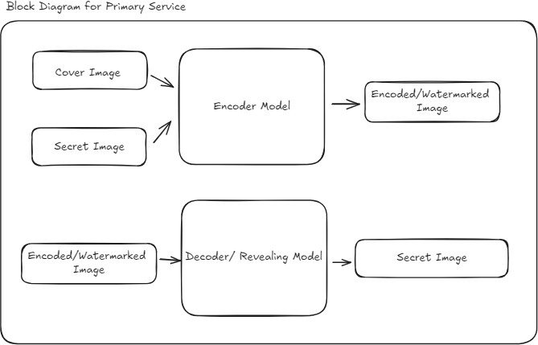

###### Fig. 1

#### Design Level Diagrams

###### Class Diagram:

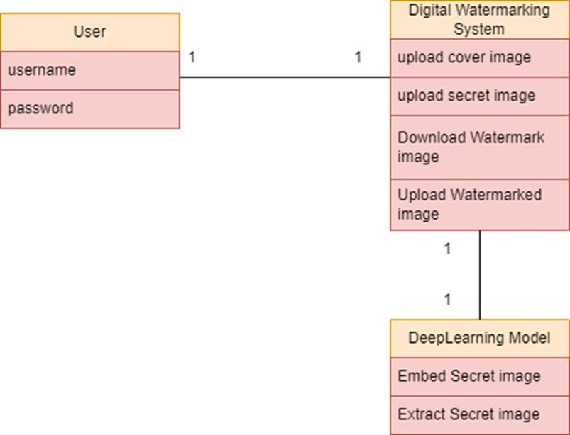

###### Fig. 2

#### User Interface Diagrams

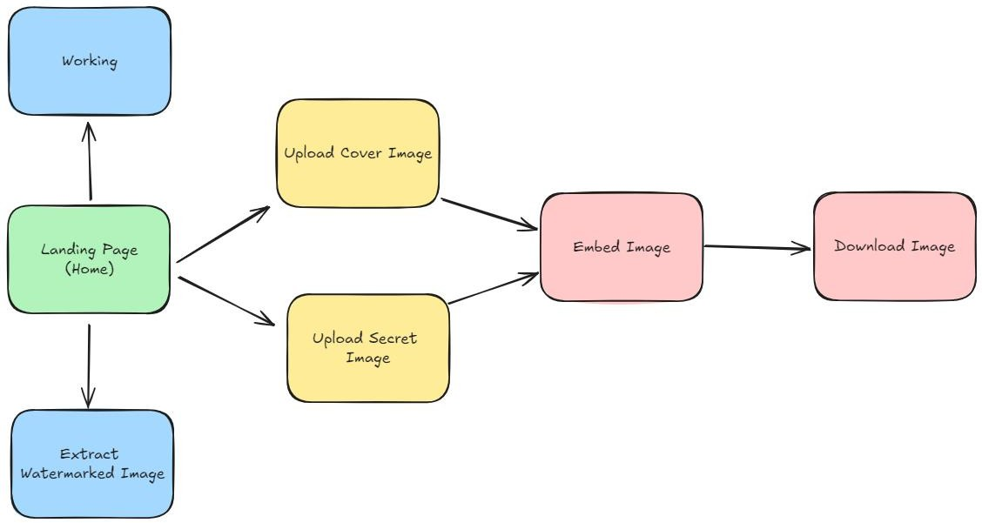

###### Fig. 3

###### Snapshots of Working Prototype

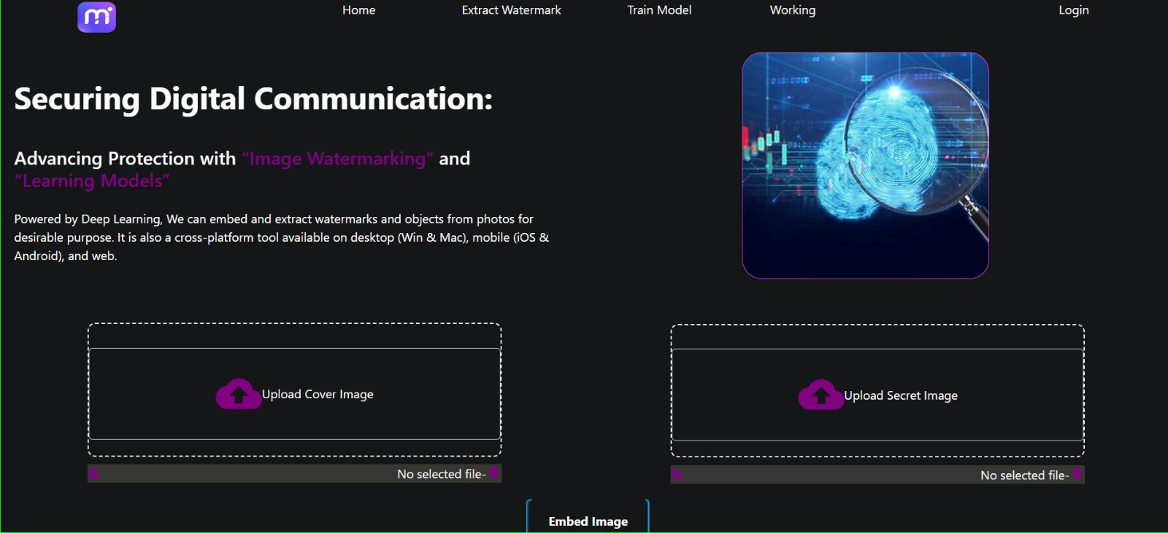

###### Fig. 4

#### Conclusions and Future Scope

###### Work Accomplished

**Discussion with respect to the approved objectives:** The primary objective of the project was to develop a robust and user-friendly image watermarking system that ensures the security and integrity of digital images. The work accomplished includes:

###### Literature Review and Analysis:

* + - * Conducted an extensive review of existing digital watermarking techniques.
      * Analyzed various case studies and existing systems to understand their strengths and weaknesses.

###### System Design and Architecture:

* + - * Developed a comprehensive system architecture, including the client, application, and data tiers.
      * Designed robust watermark embedding and detection algorithms.
      * Ensured the system's security through encryption and access control measures.

###### Development and Implementation:

* + - * Implemented the frontend using React for a responsive user interface.
      * Developed the backend with Node.js, integrating image processing and machine learning libraries with Django API.

###### Documentation and Reporting:

* + - * Prepared detailed documentation for system design, implementation, and user guidelines.
      * Generated reports on system performance and user feedback.

#### Conclusions

The development of the image watermarking system has been a significant step towards enhancing the security and integrity of digital images. The system successfully integrates advanced image processing techniques, robust watermarking algorithms, and a user-friendly interface. Key conclusions include:

###### Robustness:

* + - * The watermarking algorithms demonstrate high resistance to common image manipulations, ensuring the watermark's integrity.

###### Usability:

* + - * The user interface is intuitive and easy to navigate, making it accessible for users with varying technical expertise.

###### Security:

* + - * The system employs strong encryption and access control measures to protect user data and watermark information.

###### Performance:

* + - * The system performs efficiently, with quick response times for embedding and detecting watermarks.

###### User Satisfaction:

* + - * Feedback from user testing indicates high satisfaction with the system's functionality and ease of use.

###### Environmental, Economic, and Social Benefits Environmental Benefits:

* By promoting the use of digital watermarks, the system reduces the need for physical watermarking methods, thereby minimizing resource consumption and waste.

###### Economic Benefits:

* The system provides a cost-effective solution for securing digital images, potentially reducing losses due to image theft and unauthorized usage.

###### Social Benefits:

* Enhances the protection of intellectual property rights, benefiting content creators and publishers.
* Increases trust in digital media, encouraging more creators to share their work online.

###### Future Work Plan

###### Enhancements and Features:

###### Algorithm Improvements:

* + - * Continue research on advanced watermarking algorithms to further enhance robustness and imperceptibility.

###### Enhancing Web Application:

* + - * Extend the feature set of the web application.

###### Publication

###### Research Publication:

* + Start working on the publication of research work.

###### Expansion and Adaptation:

###### Market Expansion:

* + Expand the system's reach to different markets, including educational institutions, media companies, and legal entities.

###### Customization Options:

* + Provide customizable watermarking options to cater to specific user needs and industries.

**REFERENCES**

[1] A. Anand and A. K. Singh, “Watermarking techniques for medical data authentication: a survey,” *Multimedia Tools and Applications*, Apr. 2020, doi: https://doi.org/10.1007/s11042-020-08801-0.

‌<https://link.springer.com/article/10.1007/s11042-020-08801-0>

[2] A. Anand and Amit Kumar Singh, “A Comprehensive Study of Deep Learning-based Covert Communication,” *ACM Transactions on Multimedia Computing Communications and Applications*, vol. 18, no. 2s, pp. 1–19, Jun. 2022, doi: https://doi.org/10.1145/3508365.

‌<https://dl.acm.org/doi/full/10.1145/3508365>

[3] H. K. Singh and A. K. Singh, “Digital image watermarking using deep learning,” *Multimedia Tools and Applications*, May 2023, doi: https://doi.org/10.1007/s11042-023-15750-x.

‌<https://link.springer.com/article/10.1007/s11042-023-15750-x>

[4] M. Islam, A. Roy, and R. H. Laskar, “Neural network based robust image watermarking technique in LWT domain,” *Journal of Intelligent & Fuzzy Systems*, vol. 34, no. 3, pp. 1691–1700, Mar. 2018, doi: https://doi.org/10.3233/jifs-169462.

‌<https://content.iospress.com/articles/journal-of-intelligent-and-fuzzy-systems/ifs169462>

[5] W. Zheng *et al.*, “Robust and high capacity watermarking for image based on DWT-SVD and CNN,” May 2018, doi: https://doi.org/10.1109/iciea.2018.8397898.

‌<https://ieeexplore.ieee.org/document/8397898>

[6] Cox, I. J., Miller, M. L., & Linnartz, J. A. (2002). An overview of digital watermarking. In Principles and Applications of Digital Watermarking (pp. 3-25). Springer, Berlin, Heidelberg.

**PLAGIARISM REPORT**

**Plagiarism Check Date:** **August 24, 2024**

**Plagiarism Detection Tool:** <https://www.grammarly.com/>

**Overall Similarity Index: 5%**

**Details:**

* **Total Words: 8576**
* **Sources Identified:**

[1] “Cellular Automata Based Image Authentication Scheme Using Extended Visual Cryptography | Computing and Informatics,” *Type.sk*, 2019. <https://cai.type.sk/content/2019/6/cellular-automata-based-image-authentication-scheme-using-extended-visual-cryptography/>

[2] P. Patel, “AI-Powered Automation: The Future of Efficiency,” *Iamprem.com*, Jan. 25, 2024. <https://www.iamprem.com/2024/01/>

[3] “Security and Watermarking of Multimedia Contents III | (2001) | Publications | SPIE,” *Spie.org*, 2024. <https://spie.org/Publications/Proceedings/Volume/4314>

[4] Emmadi, N., Kattekolu, V. K., & Shamul, S. (2015). Steganography. <https://core.ac.uk/download/214311049.pdf>

[5] Manda, P. (2012). Novel Algorithms for Cross-Ontology Multi-Level Data Mining. <https://core.ac.uk/download/480812144.pdf>

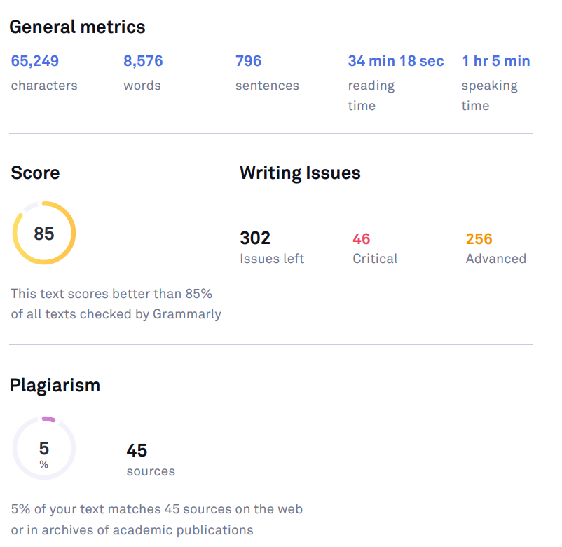

‌**Fig. 5**

**Mentors’ Approval**

